UDC 517.95
Akimov A.A., Agafonova A.A. ©
THE SOLUTION BOUNDARY-VALUE PROBLEM FOR
NONLINEAR EQUATION OF OSCILLATION BEAM
The initial boundary value problem for the nonlinear equation of beam oscillations for the case of hinged ends is considered. The problem is reduced to solving the Cauchy problem of an infinite system of ordinary differential equations. By the method of successive approximations, the existence theorem for the solution of the problem is proved.
Keywords: nonlinear equation of beam oscillations, Cauchy problem, Fourier series.
Many problems about the vibrations of rods, beams and plates, which are of great importance in structural mechanics, lead to differential equations of a higher order than the string equation. In this paper, we consider the nonlinear equation of transverse oscillations of an elastic beam, considered in a more general form [1]
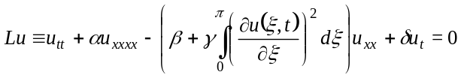, (1)
где 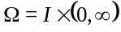, 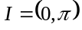 и 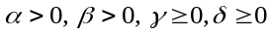, 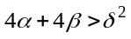.
Consider the initial-boundary problem. Find a function 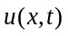 that satisfies the following conditions
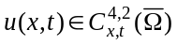; 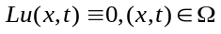; (2)
; (3)
, (4)
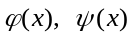− predefined functions.
In the linear case, when 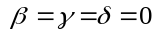, problem (2)−(4) was studied in [1]–[3].
The solution of problem (2)−(4) will be sought as the sum of the series
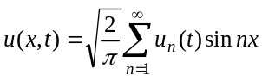.
The function 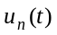 satisfies the system of equations
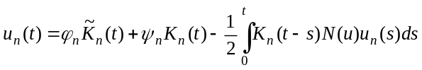,
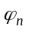 and 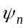 are the coefficients of the Fourier series expansion of the functions and 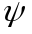 according to the system 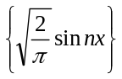,
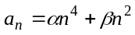,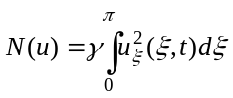,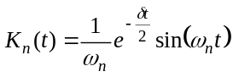, 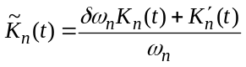, 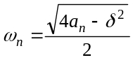.
The following theorem is proved by the method of successive approximations.
…
References
- …
Author aredentials
Akimov Andrey Anatolyevich, candidate of physical and mathematical sciences, associate professor of the Sterlitamak branch of Bashkir State University. Е-mail: andakm@rambler.ru.
Agafonova Alena Alexandrovna, student of the Faculty of Mathematics and Information Technology of the Sterlitamak branch of Bashkir State University. Е-mail: agafonova@rambler.ru.

Sample for formulas
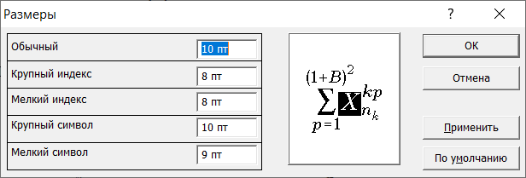

 Akimov A.A., Agafonova A.A., 2021

